TEST RESULTS :
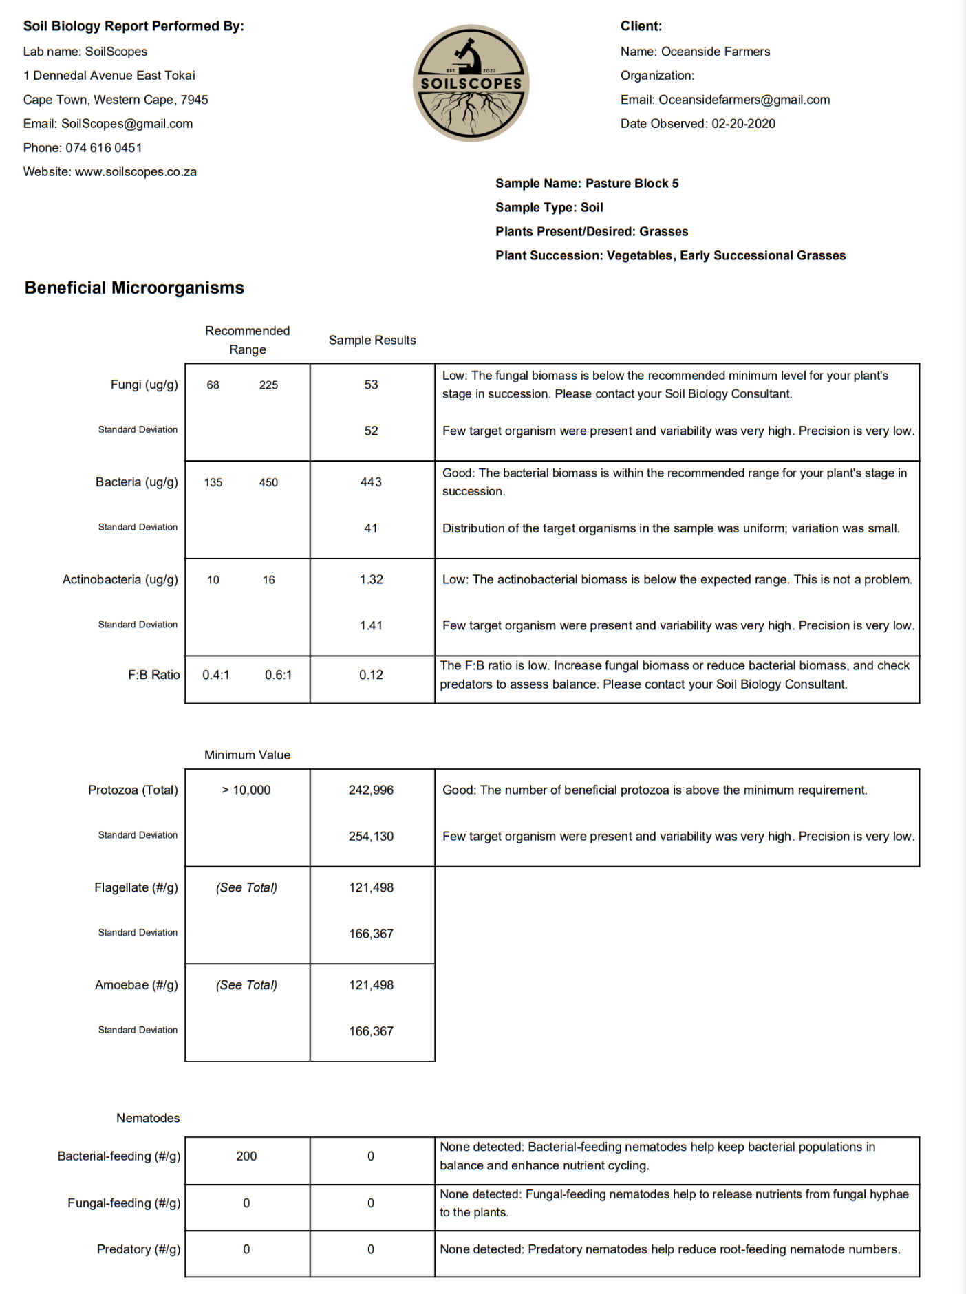

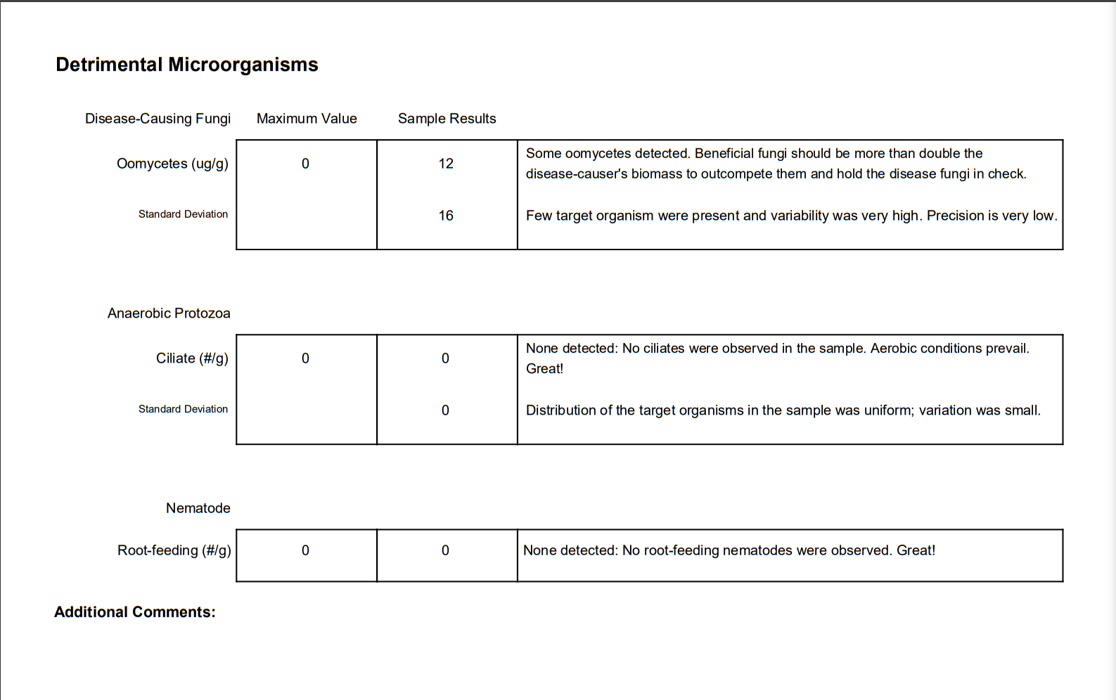

SAMPLE NAME - Pasture block 5
CLIENT NAME - Oceanside Farmers LLC
DATE - 02 - 20 - 2022
TYPE - Soil

Feedback block

- In this sample, there were good bacterial numbers and high levels of Protozoa which is great for nutrient cycling in your soil system. The high protozoa numbers are controlling the populations of bacteria well but it is likely many protozoa will go dormant as their bacterial food populations decrease.

- Fungal numbers were lower than the recommended range which is an area to work on. There are a number of benefits that fungi provide your pasture system so looking at ways to increase their numbers will yield more abundant plant growth.

- Your fungal-to-bacterial ratio is off the recommended range due to the lower fungal numbers. This needs correction to create the ideal conditions for your crops.

- There were no detectable nematodes in the sample. Having No root-feeding nematodes is great but there are many beneficial species which we would like to see. Their role is key to nutrient cycling and building soil structure so we need to find a way to introduce them into the system.

- This type of soil is common for lands which have been tilled. The low Organic matter in this sample is another area that should be addressed. There are a number of strategies to rectify this which we can discuss in our scheduled video call.

- Some Oomycetes were detected in this sample which can be an indication of low oxygen conditions in the sample. It can be a single pocket that went anaerobic or indicates some low oxygen conditions. Something to be aware of.

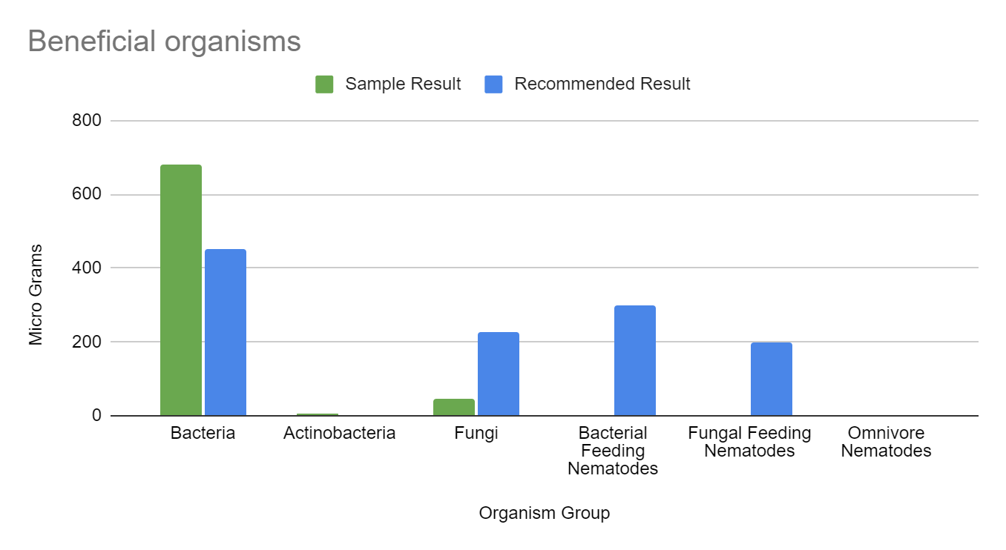

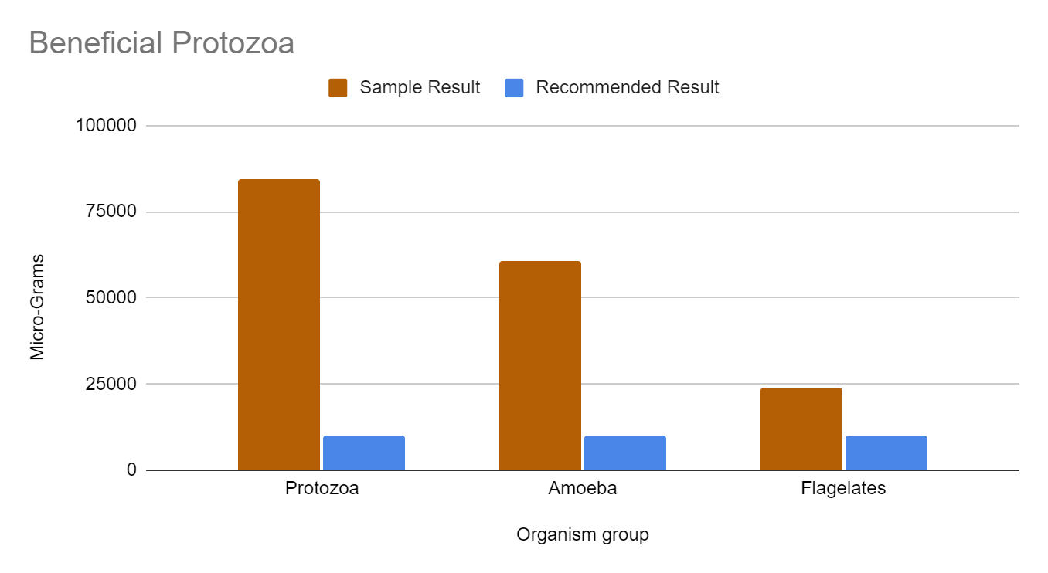

Organism checklist
Beneficial organisms
Bacteria | ✔️
Fungi | ✔️
Amoeba | ✔️
Flagellates | ✔️
Bacterial feeding Nematode | ❌
Fungal Feeding Nematode | ❌
Predatory Nematode | ❌
Facultative organisms
Actinobacteria | ✔️
Non- Beneficial organisms
Ciliates | ❌
Oomycetes | ✔️
Root Feeding Nematodes | ❌

